Instructions for Preparation of ICDS-33 Abstract

(14pt Times New Roman Bold)

**A. Author\***1**, B. Author** 1 **and C. Author** 2 **(12pt Times New Roman Bold)**

1 Affiliation1, Address1, postal code and City1, Country1

2 Affiliation2, Address2, postal code and City2, Country2

*e-mail : correspondingauthor@xxx.yyyy.zz

This document provides instructions for preparing an abstract for ICDS33 and is written according to the given guidelines. The abstract is limited in one page of A4 paper (210 mm × 297mm) including tables, figures and references. The suggested page setup for A4 paper is 2.5 cm for the left, right, top and bottom margins!

At the top of the page, type the title in **14-point Times New Roman font bold**. Leave one blank line between the title and the name(s) of the author(s). Each author's name is to be typed in **12-point Times New Roman font bold**. For multiple authors from different affiliations, identify each author with a superscript number placed after the author's family name. Underline the **corresponding author**. Leave one blank line between the author(s) and the affiliation(s) associated with each author. The superscript number typed at the end of each author's name should correspond to the superscript number typed at the beginning of the affiliations. Provide the e-mail address of corresponding author. This block is to be typed in 12-point Times New Roman font. The title, author, affiliation and e-mail lines are to be centered. Leave one blank line after the affiliation block, then start text body using 12-point Times New Roman font (and Symbol or similar fonts, if necessary) and single spacing. Indicate references, using numbers enclosed in square brackets, e.g. [1]. List the references at the end of the text. The suggested style is given below.

**Abstracts must be written in English, and submitted before March 31, 2025**. After reviewing, acceptance notices will be emailed on May 31, 2025 to the corresponding author.

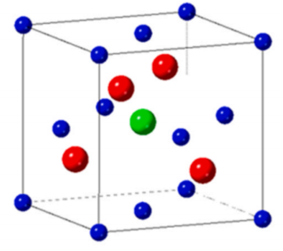

Table 1: Description of Table 1.

|  |  |  |
| --- | --- | --- |
|  | *Description1* | *Description 2* |
| *Row 1, Col 1* | *Row 1, Col 2* | *Row 1, Col 3* |
| *Row 2, Col 1* | *Row 2, Col 2* | *Row 2, Col 3* |
| *Row 3, Col 1* | *Row 3, Col 2* | *Row 3, Col 3* |

Fig. 1: Description of Figure 1.

**Reference:**

[1] A. Author1, B. C. Author2 and J. Auth3, Appl. Phys. Lett*.* **85**, 123 (2016).